# 1. Create Your own Resume data in, JSON Format.

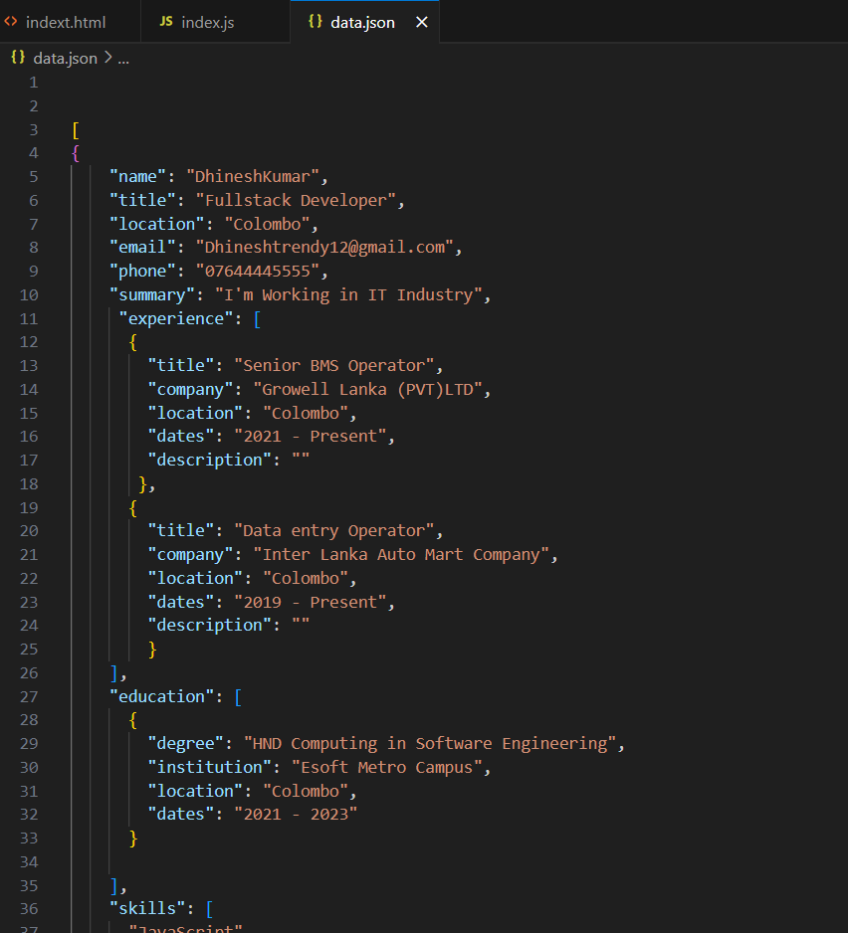

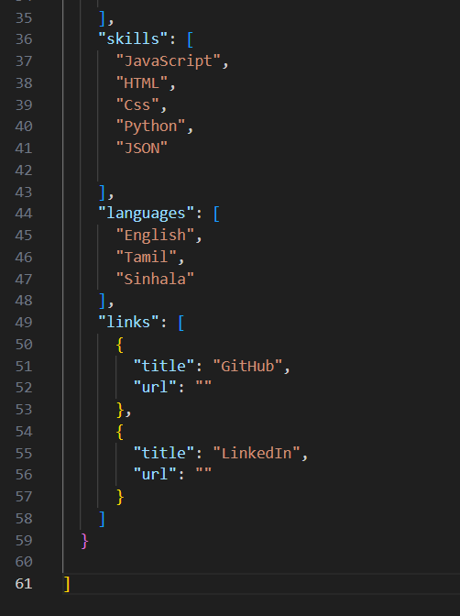

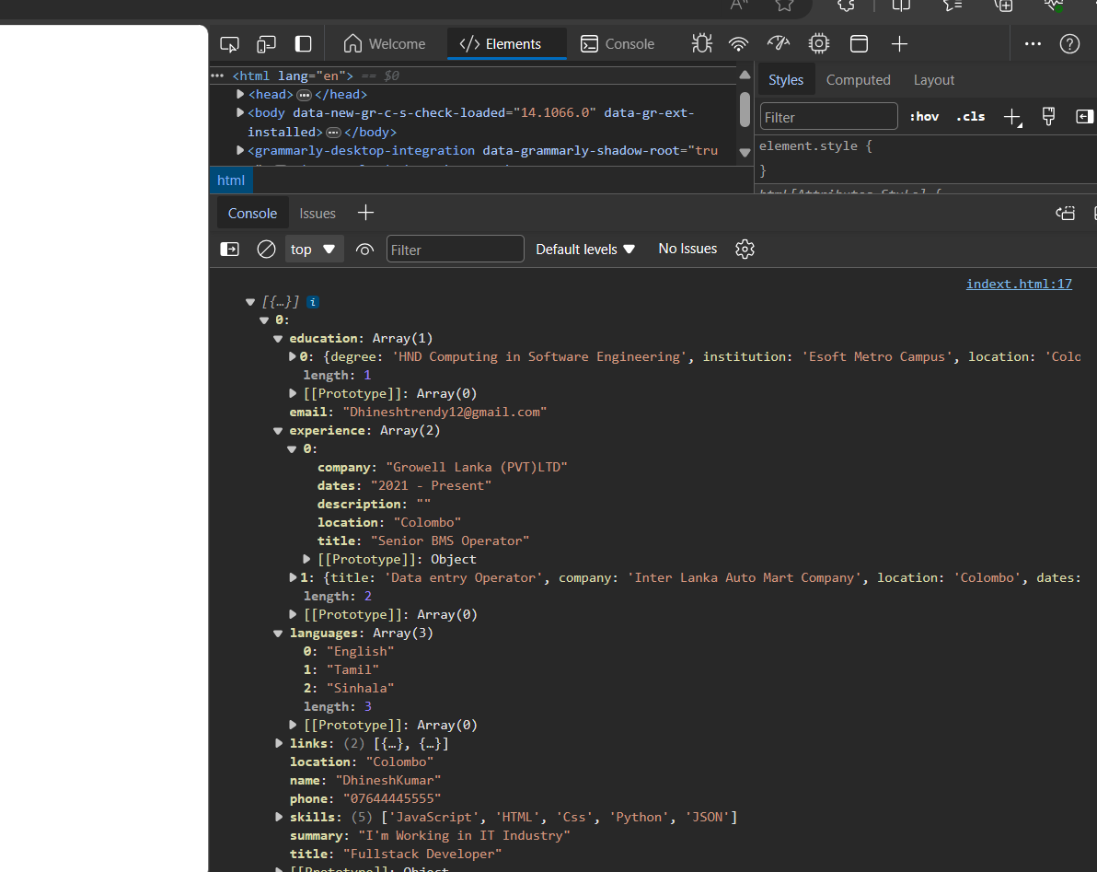

# 2. for the above JSON, iterate over all for loops (for, for in, for of, forEach).

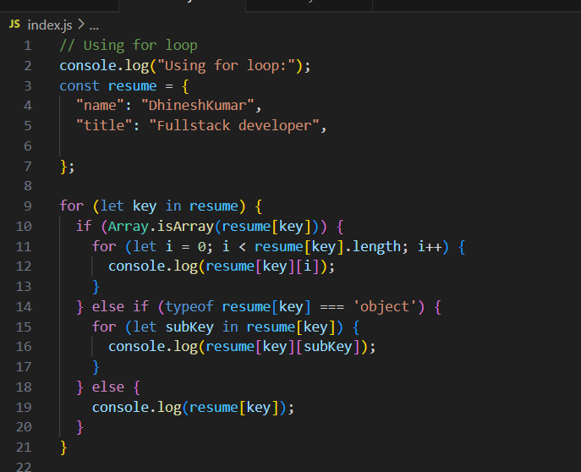

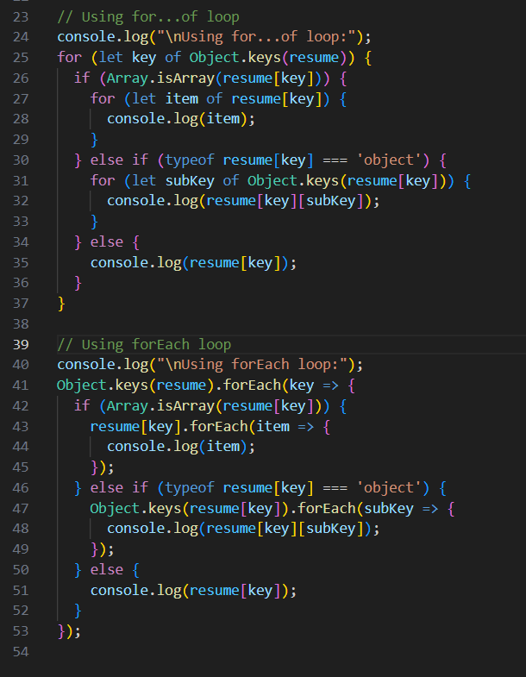

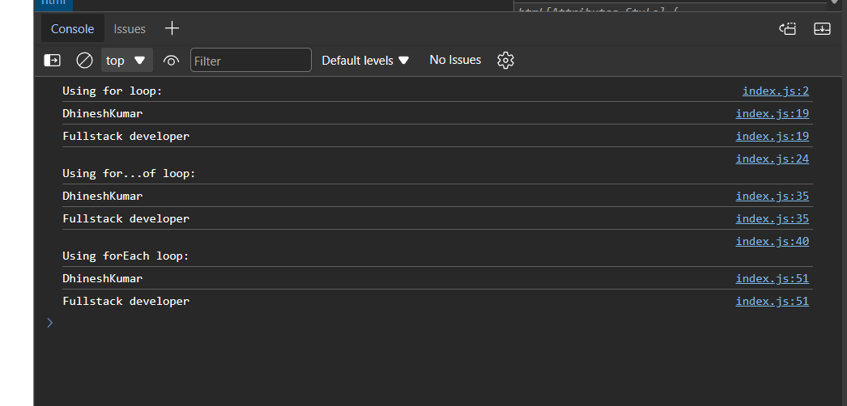

# 3. Read about the difference between window, screen, and document in JavaScript.

|  |  |
| --- | --- |
| **Window** | In a browser environment, `window` represents the browser window that contains the DOM document. It's the global object and serves as the top-level browsing context. It provides properties and methods related to the browser window, such as `window. location`, `window. alert()`, etc. In Node.js, `window` is not available as it represents the browser environment. |
| **Screen** | The `screen` object provides information about the user's screen, such as its dimensions (`screen. width`, `screen. height`), pixel depth, and color resolution. It's a property of the `window` object. |
| **Document** | The `document` object represents the DOM (Document Object Model) of the current web page loaded in the browser. It provides methods and properties to interact with the content of the page, such as selecting elements (`document.getElementById()`, `document.querySelector()`), manipulating HTML (`document.createElement()`, `document.appendChild()`), and handling events (`document.addEventListener()`). |